Chapter 19, Solution 29.

In the bridge circuit of Fig.19.87, I₁ = 10 A and I₂ = -4A.

a) Find V₁ and V₂ using y parameters.
b) Confirm the results in part (a) by direct circuit analysis.

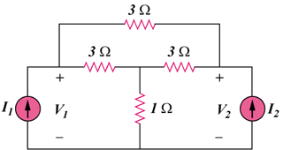

Figure 19.87
For Prob. 19.29.

Solution

- Transforming the subnetwork to Y gives the circuit in Fig. (a).

-4 A

2

1

1

10 A

V_{o}

+

V₁

+

V₂

(a)

It is easy to get the z parameters
, ,

,

Thus, the equivalent circuit is as shown in Fig. (b).

-4 A

1/5 S

2/5 S

10 A

+

V₁

+

V₂

(b)

1/5 S

I₁

I₂

(1)

(2)

Substituting (2) into (1),

- For direct circuit analysis, consider the circuit in Fig. (a).

For the main non-reference node,

